ECS795P Deep Learning and Computer Vision, 2018

**Course Work 1: Image Super-resolution Using Deep Learning**

1. Suppose the settings of a SRCNN as: f1=9, f2=3, f3=5, how many pixels of the low-resolution image are utilized to reconstruct a pixel of the high-resolution image with the SRCNN? (10% of CW1)

The estimation of a high resolution pixel utilizes the information of (9 + 5 − 3)**2 = 121 pixels.

1. Why the deep convolutional model is superior to perform image super-resolution? Give one reason to explain it. (10% of CW1)

Three operations: patch extraction and representation, non-linear mapping and reconstruction - are motivated by different intuitions, but they all lead to the same form as a convolutional layer. Another words, this essential operations for solving the task can be ideally reformulated into a CNN.

1. Please explain the physical meaning of peak signal-to-noise ratio (PSNR) in the context of image super-resolution. PS: place here the ground truth (GT) image, and the high-resolution images by SCRNN (HR-SRCNN) and bicubic interpolation (HR-BI) for reference. Also put the PSNR value below the high-resolution images. (10% of CW1)

PSNR is calculated using the Mean-Square-Error (MSE) of the pixels in a refurbishment image and the maximum possible pixel value (MAXI) in original image as follows:

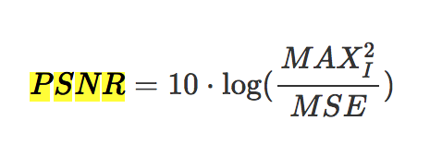

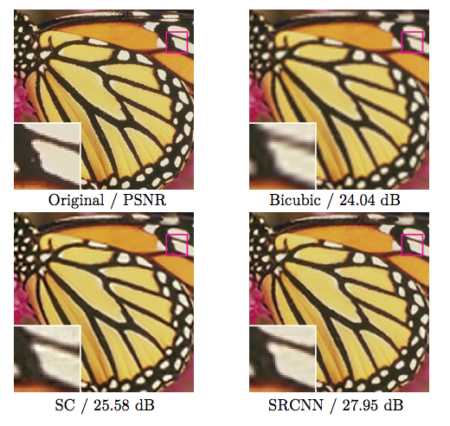

Physically it means that image is more precise if it has higher resolution.

|  |
| --- |
| GT (original) |
| HR-BI (PSNR=24.04 dB) |
| HR-SRCNN (PSNR=27.95) |